App Store Version 3 database created successfully along with the tables:

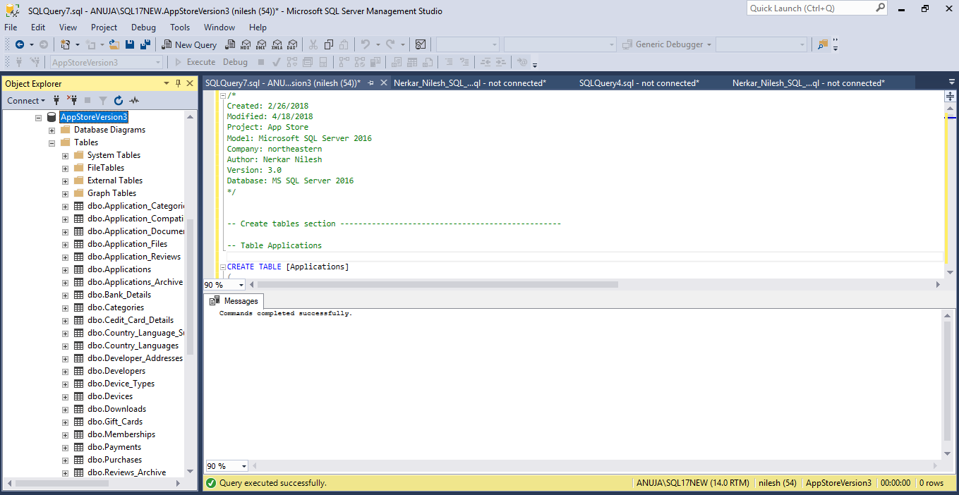

Created new table Admin_Credentials as toad does not allow more than 25 tables:

